# **My Dream Computer**

## **Hard drive**

* **Hardware component that stores all of my digital content.**

**Suggested specification: Toshiba Product Series:DT01ACA 1TB 3.5" 7200RPM. [1]**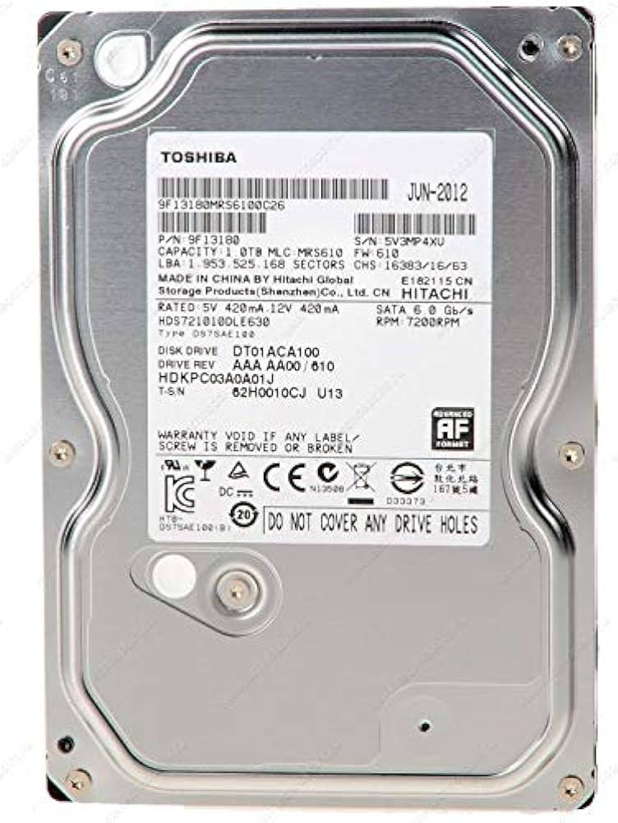

## **CPU**

* **The Central Processing Unit is the primary component of a computer that acts as its “control center”.**

**Suggested specification: Intel Core i7-5930K 3.5GHz 6-Core Processor. [2]**

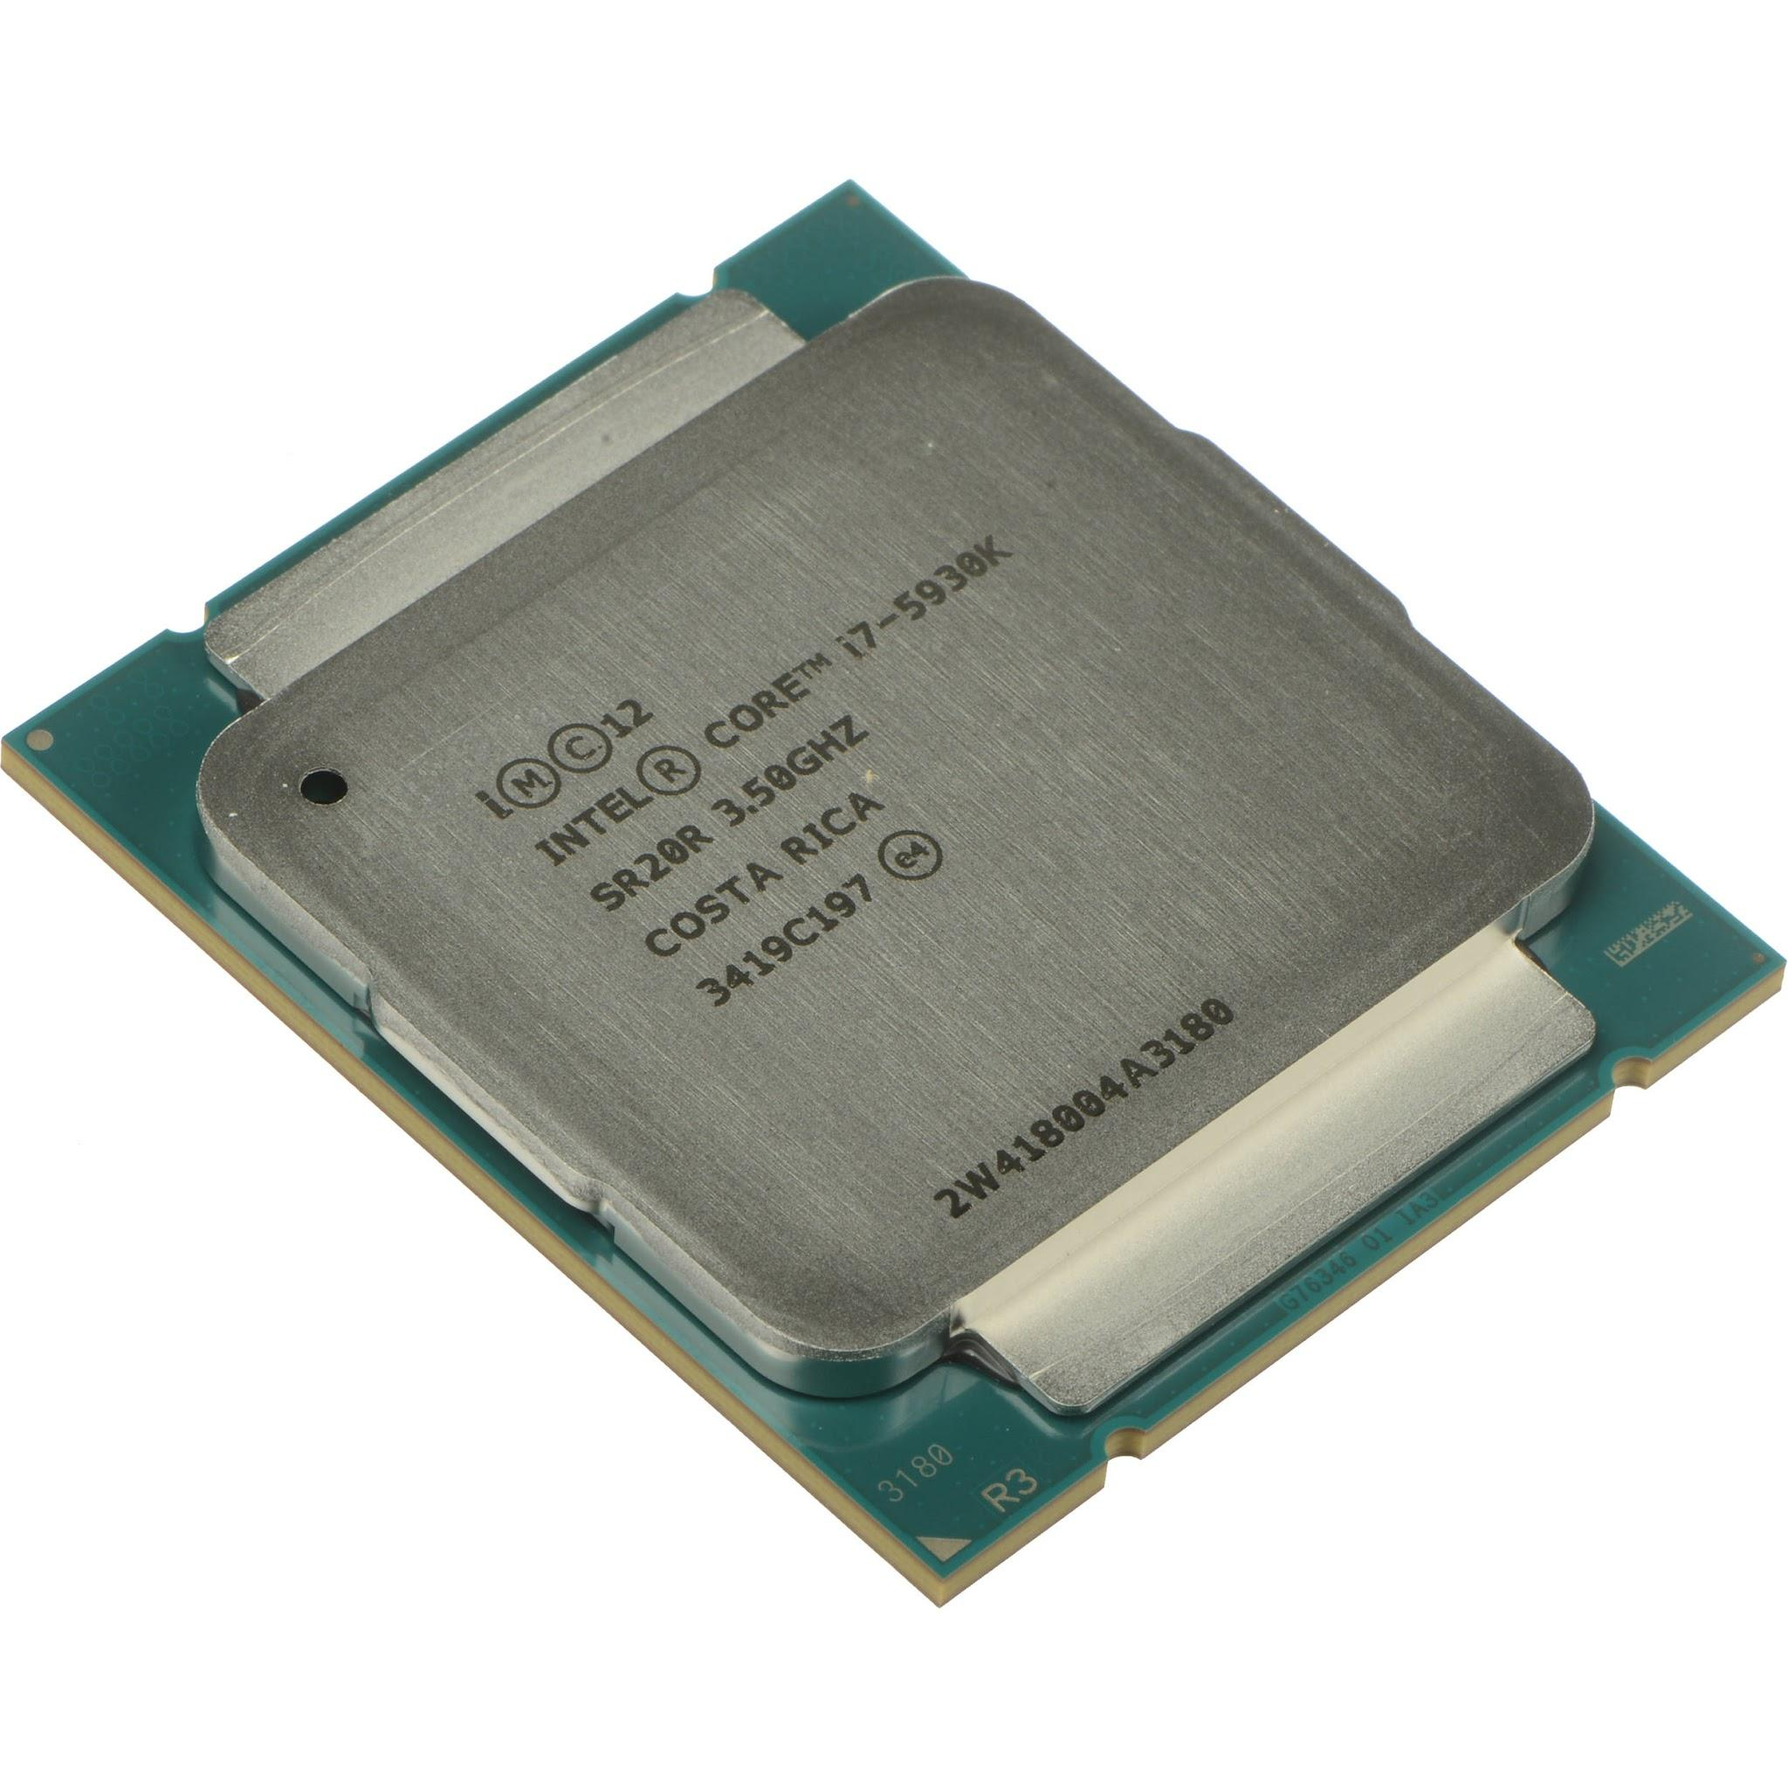

## 

## **Memory**

* **RAM is the main memory in a computer. It is much faster to read from and write to than other kinds of storage.**

**Suggested specification: G.Skill Ripjaws 4 series 16GB (4 x 4GB) DDR4-2800. [3]**

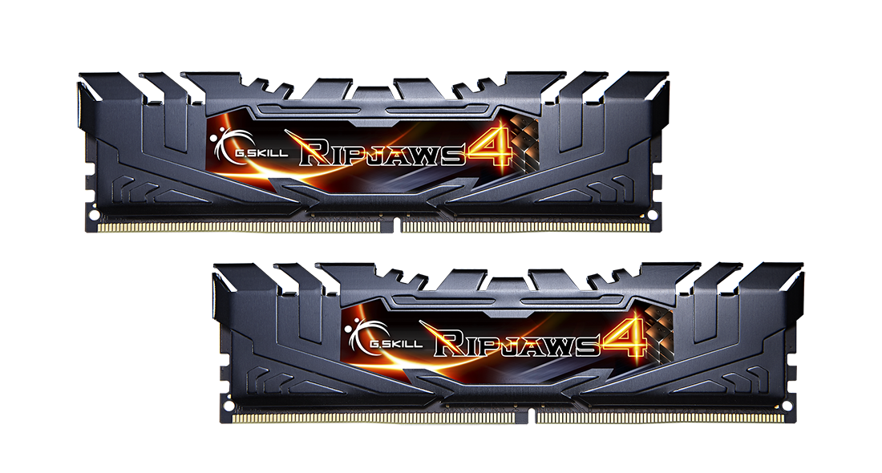

## 

## 

## 

## 

## **GPU**

* **Graphics processing unit, a specialized processor originally designed to accelerate graphics rendering.**

**Suggested specification: ASUS GeForce GTX 960 Overclocked 4 GB DDR5. [4]**

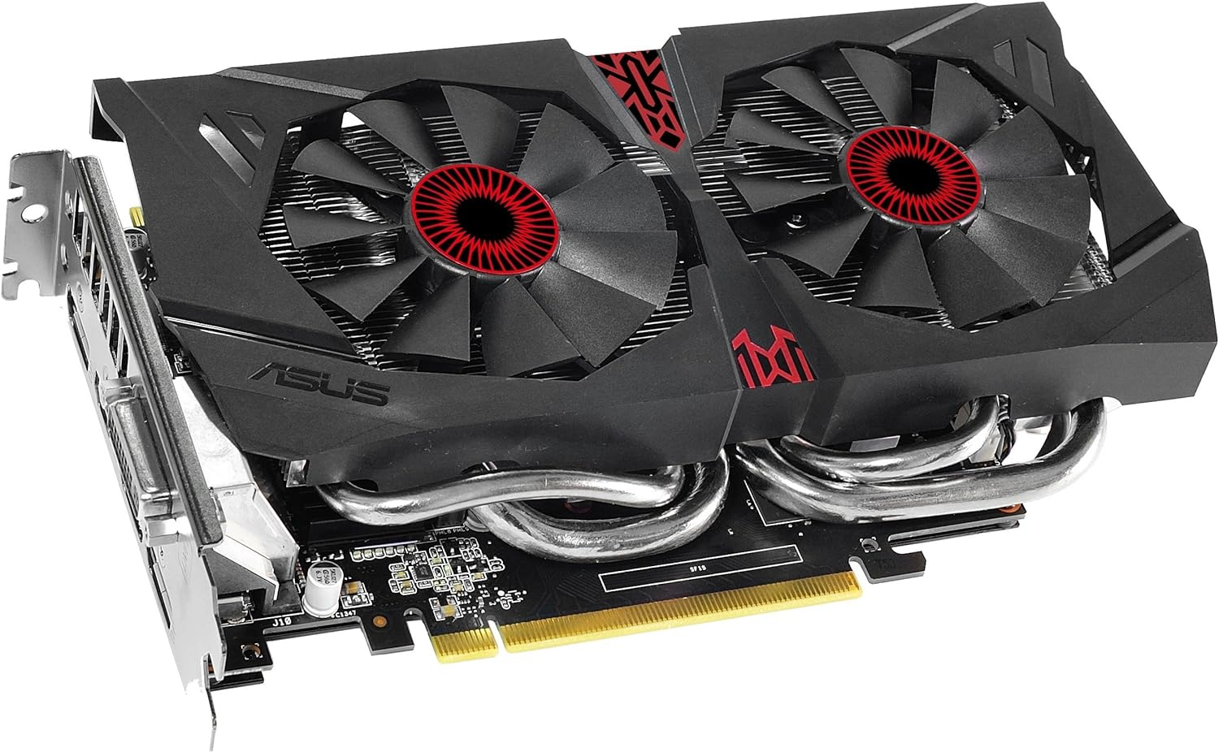

## **Motherboard**

* **A motherboard is the main printed circuit board (PCB) in general-purpose computers and other expandable systems..**

**Suggested specification: Gigabyte GA-X99-SLI ATX LGA2011-3. [5]**

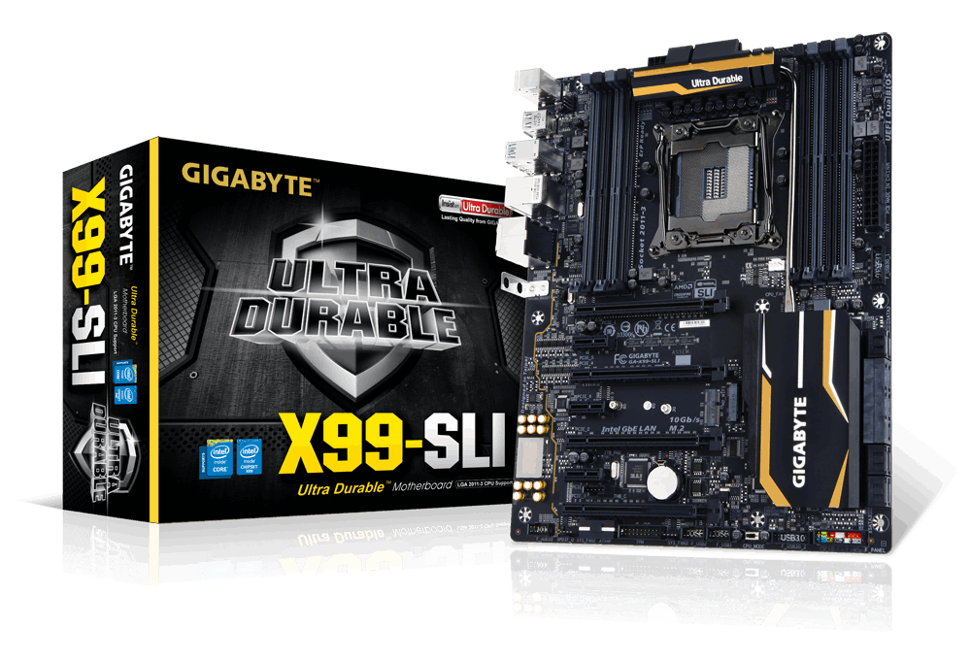

1. <https://www.amazon.eg/-/en/TOSHIBA-DT01ACA100-Internal-Drive-Cache/dp/B098TXKRS6>
2. <https://www.bhphotovideo.com/c/product/1080333-REG/intel_bx80648i75930k_intel_core_i7_5930k_3_5.html>
3. <https://www.gskill.com/product/165/172/1535954240/F4-2800C16Q-16GRK-EOL>
4. <https://www.amazon.com/GeForce-Overclocked-128-bit-DisplayPort-Graphics/dp/B00VRSERUI?th=1>
5. <https://www.gigabyte.com/Motherboard/GA-X99-SLI-rev-10#ov>